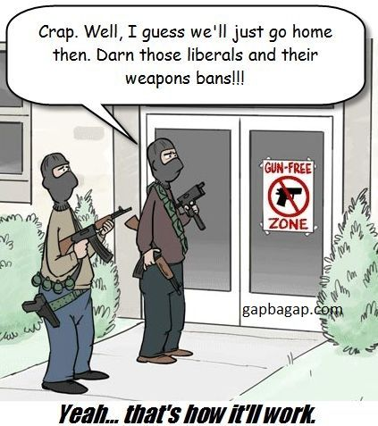

Banning guns will not stop criminals from obtaining Owning a firearm is a first line of
and using guns, It will only make law abiding defense, average police time is
Citizens unarmed and less safe 9.1 minutes.
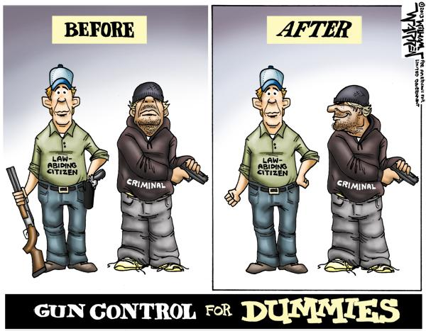

Gun control will only take away guns from those Training law abiding citizens to use guns
who follow the law correctly and responsibly will make them
safer, banning guns will not. Lets use
true “gun control”

